Symphony (MDx) Test Automation

Contents

1. ABOUT THIS DOCUMENT 2

2. GLOSSARY OF TERMS 2

3. INTRODUCTION TO PROJECT 2

4. PROJECT LEVEL PRE-REQUISISTES 3

5. AUTOMATION SCOPE DETAILS………………………………………………………….4

6. SME DETAILS…………………………...…………………………………………………. 5

7. AUTOMATION FRAMEWOK…………………………..………………………………….6

8. AUTOMATION DESIGN PROCESS………..……………………………………………..10

9. AUTOMATED SCRIPTS EXECUTION PROCESS…………………………………….....12

10. REFERANCE TEMPLATES……………………………..…………………………………13

11. DOCUMENT VERSION CONTROL TABLE……………………………………………..13

# ABOUT THIS DOCUMENT:

This is an internal document between two GE entities – The Corporate Testing COE and GE Healthcare SAP COE. It also explains about GE Healthcare Project Symphony Test Automation and the roles & responsibilities of the tester. This document will assist the automation resource, who is going to work on preparation, design/maintenance & execution of existing and future scripts.

# GLOSSARY OF TERMS:

|  |  |  |
| --- | --- | --- |
| Acronym | Term | Definition |
| Informal ALM | Informal Application Lifecycle Management Tool | It is an Informal project in Test management software offered by HP Software, where the automated test script design & Dry runs will be done to make sure the script works as excepted. |
| Formal ALM | Formal Application Lifecycle Management Tool | It is a Formal project in Test management software offered by HP Software, where the completely automated test script are present and are used for every execution in every regression Testing. |
| COE | Center of Excellence | A GE entity that provides leadership, best practices, research, support and/or training for a focus area. |
| VM | Validation Manager | A Person who is responsible to for Final Sign-off the Automated Test scripts |

# INTRODUCTION TO PROJECT:

|  |  |
| --- | --- |
| **Project Name** | Test Automation -Symphony(MDx -Medical Diagnostics) |
| **GE Business** | GE HealthCare |
| **GE Leader in Business** | Nawracaj, Piotr (212405596) |
| **GE Leader in TCoE** | Talikota, Satish (212363836) |
| **GDC Lead** | Talari, Surendra (502282139) |
| **No.of.Scripts In-Scope for Automation Design** | 22 |
| **ALM URL** | http://3.232.214.74:8080/qcbin/start_a.jsp |
| **Domain** | SAPGLOBAL |
| **Informal Project** | Informal_Testing_NonGxP |
| **Formal Project** | SAPGlobal_Testing_GxP |

# PROJECT LEVEL PRE-REQUISISTES:

1. **ADN account creation for Health care SSO**

Resource should have ADN created followed by Health care SSO in order to start the activities in Healthcare project. Sponsor from HealthCare Business is responsible for creation of AND Account and SSO for the Resource.

1. **Mandatory Trainings**

The Resource who is going to work/access project related documents should complete the list of mandatory trainings proposed by business. Below is the list of trainings as per 2013 records.

|  |  |  |
| --- | --- | --- |
| **Course Type** | **S. No** | **Course Name** |
| **ALM** | 1 | [GEHC ITPE ALM Test Management Module Code: GEHC-ITPE-731754-rev2_CURR](https://ge.sumtotalsystems.com/sumtotal/app/management/LMS_ActDetails.aspx?UserMode=0&CallerURL=/sumtotal/app/management/LMS_LearnerReports.aspx%3FUserMode%3D0&ActivityId=166075) |
| 2 | [SPIRIT AND LETTER YOUR PERSONAL COMMITMENT Code: GE-LEGAL-CEL-ACK](https://ge.sumtotalsystems.com/sumtotal/app/management/LMS_ActDetails.aspx?UserMode=0&CallerURL=/sumtotal/app/management/LMS_LearnerReports.aspx%3FUserMode%3D0&ActivityId=13544) |
| **Computerized System Validation for Non-Product Software** | 3 | GEHC-QUAL-QMS-GLOBAL-CM2800 & GEHC-QUAL-QMS-GLOBAL-CM2800-EXAM-OBJECTIVE |
| **QMS Courses** | 4 | GEHC-QUAL-QMS-GLOBAL-QMSManual_CURR |
| 5 | [IT Standard - Risk Management Rev 5 Code: GEHC-IT-QMS21536618-Rev5_CURR](https://ge.sumtotalsystems.com/sumtotal/app/management/LMS_ActDetails.aspx?UserMode=0&CallerURL=/sumtotal/app/management/LMS_LearnerReports.aspx%3FUserMode%3D0&ActivityId=158966) |
| 6 | GEHC-QUAL-QMS |
| 7 | GEHC-QUAL-QMS-GLOBAL-QSO_CURR |
| 8 | [Good Documentation Practices Course (Rev 4) Code: GEHC-QUAL-QMS-GLOBAL-CM2804_CURR](https://ge.sumtotalsystems.com/sumtotal/app/management/LMS_ActDetails.aspx?UserMode=0&CallerURL=/sumtotal/app/management/LMS_LearnerReports.aspx%3FUserMode%3D0&ActivityId=18085) |
| 9 | GEHC-QUAL-QMS-GLOBAL-CM2813_CURR |
| **IT Compliance** | 10 | GEHC-IT-QMS21536241_CURR (ITPE Good Documentation Practices) |
| **Courses** | 11 | [IT Standard - Testing Rev5 Code: GEHC-IT-QMS21537125-Rev5_CURR](https://ge.sumtotalsystems.com/sumtotal/app/management/LMS_ActDetails.aspx?UserMode=0&CallerURL=/sumtotal/app/management/LMS_LearnerReports.aspx%3FUserMode%3D0&ActivityId=159226) |
|  | 12 | GEHC-IT-IT731-EN |
| **My Workshop** | 13 | GEHC-MTP-BUC-MWS-EPDM1_CURR |
| 15 | Test Strategy for SAP ERP Standard Operating Model - DOC0217676 |
| 16 | Integrations Guidelines - DOC0643670 |
| 17 | ITPE Compliance Standard (Read & Understand) - DOC1313198 |
| 18 | Introduction to Validation Course: SAPERP_TSP_VN_0002_4.2 - DOC0217011 |

1. **ALM Access :**

Resource will get ALM Access after successful completion of Mandatory trainings and submission of Training summary Report to business.

1. **SAP Instance Access :**

Resource will get SAP Instance Access after successful completion of Mandatory trainings and submission of Completion Report to business.

# AUTOMATION SCOPE DETAILS:

Below are the list of scripts given for Automation and their current status.

|  |  |  |  |
| --- | --- | --- | --- |
| **S.No.** | **Test cases Name** | **Automation Status** | **Comments** |
| 1 | SAPERP_RTS_PU_0105_External Procurement of Stock Material | Completed & Closed |  |
| 2 | SAPERP_RTS_PU_0106_Intra-company Purchases | Completed & Closed |  |
| 3 | SAPERP_RTS_PU_0108_Third Party Orders | Completed & Closed |  |
| 4 | SAPERP_RTS_WH_0016_UK_RF_HU_PICKING | Completed & Closed |  |
| 5 | SAPERP_RTS_WH_0014_DE_Prepack_and_Final_Pack | Completed & Closed |  |
| 6 | SAPERP_RTS_WH_0010_Bulk Picking Contrast Media | Not Automatable | Inconsistency in Functional Flow |
| 7 | SAPERP_RTS_PU_0107_Inter-company Purchases | Completed & Closed |  |
| 8 | SAPERP_RTS_CF_0017_UK_Goods_Receipt_Raw_Materials | Completed & Closed |  |
| 9 | SAPERP_RTS_FI_0072_Accounts Payable | Completed & Closed |  |
| 10 | SAPERP_RTS_FI_0071_Controlling activities | Completed & Closed |  |
| 11 | SAPERP_RTS_FI_0070_Acquisition and Settlement of Asset Under Construction | Completed & Closed |  |
| 12 | SAPERP_RTS_MF_0100_Auto Update Batches with DUD | Completed & Closed |  |
| 13 | SAPERP_RTS_MF_0106_Capacity_Levelling | Completed & Closed |  |
| 14 | SAPERP_RTS_MF_0101_Proc_Ord_Dom_Prod_Solution_to_Halb | Replaced by CF_0013 | Automatable |
| 15 | SAPERP_RTS_MF_0102_Complete_process_order_cycle_PI_sheet_CRD_5 | Replaced by CF_0013 | Automatable |
| 16 | SAPERP_RTS_MF_0105_Proc_Ord_Date_change_with_impact_check | Completed & Closed |  |
| 17 | SAPERP_RTS_CS_0103_Master Data SD-FI | Completed & Closed |  |
| 18 | SAPERP_RTS_CS_0107_LIS up-date | Completed & Closed |  |
| 19 | SAPERP_RTS_CS_0100_Inter-company billing Oslo - Shanghai | Completed & Closed |  |
| 20 | SAPERP_RTS_CS_0101_Return goods from customer consignment stock and scrap the goods | Completed & Closed |  |
| 21 | SAPERP_RTS_CS_0104_Posting from SD to FI | Completed & Closed |  |
| 22 | SAPERP_RTS_CS_0105_Customer return | Completed & Closed |  |
| 23 | SAPERP_RTS_CS_0106_Customer consignment stock | Completed & Closed |  |
| 24 | SAPERP_IF-RTS_APO_0010_APO End to End | Replaced by CF_0013 | Semi-Automatable |
| 25 | SAPERP_RTS_CF_0010_Datscan Despatch to domestic and UK customers | Semi-Automatable |  |
| 26 | SAPERP_RTS_CF_0016_Drytec_without_interface | Semi-Automatable |  |
| 27 | SAPERP_RTS_FI_0074_Finance_Period_End_Close | Semi-Automatable |  |
| 28 | SAPERP_RTS_MF_0103_Proc_Ord_Comp_Batch_Expiry_Date_Variant_Rework | Semi-Automatable |  |
| 29 | SAPERP_RTS_MF_0108_Plant_1000_Forecast_load_and_MRP | Semi-Automatable |  |
| 30 | SAPERP_RTS_CF_0013_Theracap E2E process for despatch to SAP countries | Completed & Closed |  |

# SME DETAILS:

|  |  |  |  |
| --- | --- | --- | --- |
| **S.No** | **Functional Area** | **First Contact (Name &SSO  id)** | **Functional Lead (Name & SSO id)** |
| 1 | Manufacturing(MF) | Kuntamukkala, Mallika( 502538235) | Sandy  (100018071) |
| 2 | Procurement(PU) | Thimmappa, Chalapathi (502327586), Kosana, Visalakshi (502434806) | Helena (100025397) |
| 3 | Customer Service(CS) | Kamakchi, Muthu (502098314) | Phil T (100025873) |
| 4 | Freight and Distribution(FD) | Kamakchi, Muthu (502098314) | Phil T (100025873) |
| 5 | Finance(FI) | Jogipet, Ramakrishna(501765748) | Jan (100020701) |
| 6 | Warehouse Management(WH/WM) | Thimmappa, Chalapathi (502327586) | Colin(100018824) |
| 7 | Quality Management(QM) | Kuntamukkala, Mallika( 502538235) | Sandy  (100018071) |
|  |  |  |  |

# AUTOMATION FRAMEWOK:

The below Process describes how to use QuickTest(QTP) to develop and execute Automation Scripts for all HealthCare applications. Step-by-step instructions provided will help you in understanding the execution flow of test scripts.

**Hybrid Framework Automation Folder Structure**:

In order to maintain all the files created in automation like Configuration files, library files, QTP Scripts, Result Files etc. we would require a suitable folder hierarchy. Hence we have created a root folder for this Framework with the following folders, which is shown below screenshot.

1. Configuration
2. FunctionLibrary
3. Screenshot
4. TestData
5. TestScript

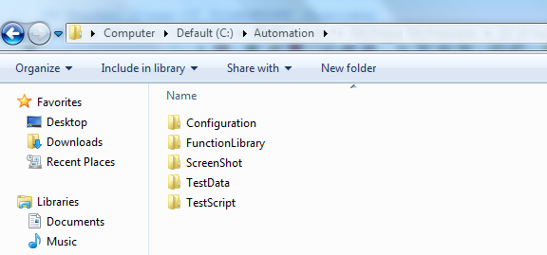

1. **Configuration:**

**Configuration** Folder contains the ini file with the System Details, User login credentials and QC Details. The purpose of this file is to help us to manage/modify the User Login details. For example, if we want to run the created scripts on one System, the same can be run on other system by simply replacing the system details in ini file.

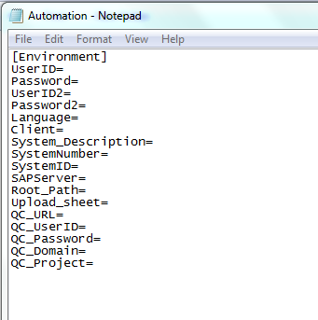

1. **2.Function Library:**

This Folder contains the following library VBS file(.VBS). The purpose of these libraries is to avoid redundancy in scripting and also helps us to Reuse the script easily by calling those functions. These library file consists of generic functions which can be used for operations like, Reporting format, dealing with Excel file and Base functions to perform object level operations etc.

* Generic_Functions

**Note**:

* All the library file(s) have to be added in resource tab in test setting window comes through navigation **File🡪Setting**. Add library file and make default so that it will be common to all the scripts. All scripts should contain the above mentioned library file(s) as default.
* Use **SetAsDefault** option in test Settings so that the libraries files will be associated for all Tests/Actions etc.
* Take the Backup of Libraries whenever there is any modification done to the existing libraries.

**File🡪Settings:**

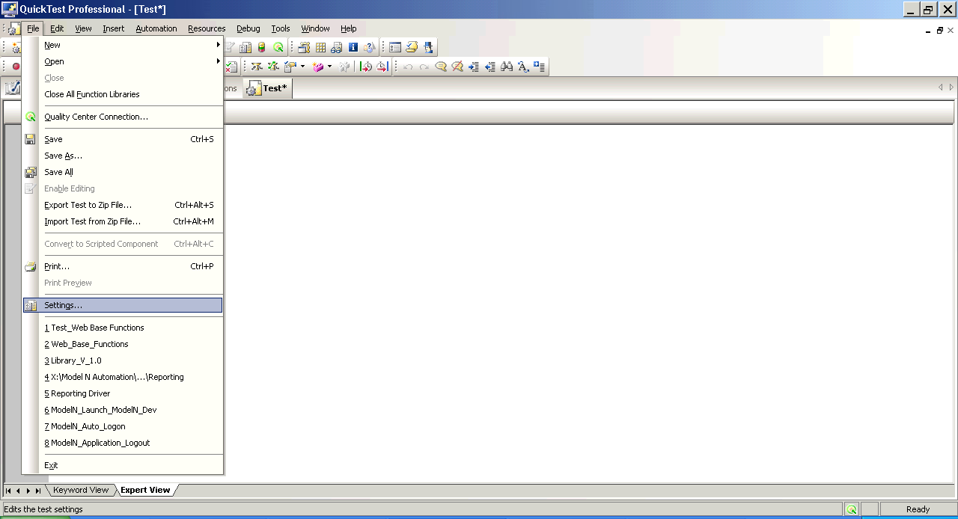

1. **Screenshot:**

Folder contains Subfolder with Test script name. During the execution the Captured screen shots will be saved in the respective test script folder. Later, these screen shots are attached in same sequence to the particular run in Test lab of HP QC.

1. **Test Data:**

TestData folder contains the Test case specific test data information saved in excel sheet. Each test script has its own test data file saved in this folder.

Standard naming convention for Column names should be followed across all the test data sheet and the Parameter names should be always be in Capital letters and start with “**DT_”.** The output parameter name should be given as “**DT_OUTPUT**”.

Color coding has been assigned to the parameters while uploading test data to the Quality Center. The input parameters highlighted in Yellow color while the Output is highlighted in Green.

**E.g.: DT_USERNAME, DT_TEST_SET_ID, DT_OUTPUT_DELIVERY** etc.

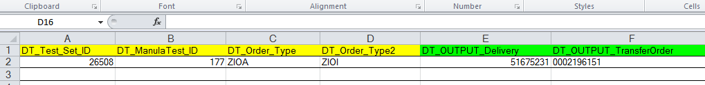

**Note**:

* Maintain a single and unique test data file for each driver script.
* Maintain the name of **Test Data file** for each script same as **Automation Test Script name.**
* **Initialize_Action** is used to Import the test data sheet into runtime data table. Component gets the test data sheet path from the environment variable (Environment (**Test Name**)). **There is no need to provide the Test data file path in the test script.**
* Every driver script consists of **Initialize_Action** component which internally loads the test data sheet into QTP run time data table during execution.
* For that we need to make sure that **Test Data file** name should be same **test Script name** so that the same name can be retrieved from Environment variable **(Environment. Value (“Test Name”))** during execution. If we change the name of Test Data file (not as like Driver Script name), the “**Initialize_Action”** component doesn’t import the data sheet into run time data table and the execution will be failed there itself.

1. **Test Script:**

This folder contains list of the all the Automated Test Scenarios

**Reusable Scripts:** Reusable Script is a QTP test which has a single reusable action.

Reusable Actions are of 2 types,

1. Common Actions
2. Application Specific Actions

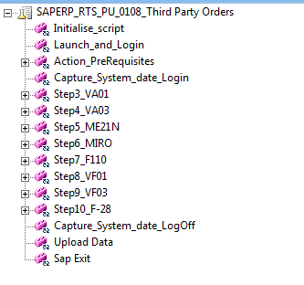

**Common Actions**:

These Actions are developed for performing the common activities related to the Application such as, Initializing the Scripts, Launching & Login into the Application, LogOff & Exporting Input/output Test Data to the HP Quality Center

**Note:** Reusable Actions saved in Common Actions folder are useful for development of all the scripts during the automation process of application

**Application Specific Components:**

This folder is used to save/store the Reusable Actions developed as per the test cases. These actions are specific to each test case/driver script.

Based on the functional flows of the test case, a script can be divided into number of blocks. Each block has meaningful and reusable functionality. For each block one Reusable action should be developed.

1. **Results Files:**

After executing the driver script from QTP/Quality Center, the Automation Script performs the operations based on the description provided in the Manual Test Case and verifies the output of the Application against the Expected Results in the Manual Test Case. The run-time data along with the verification result will be added to actual result of Manual Test Case in step wise.

For verification purpose we have below two kinds of Results available for Each Test Script after execution

1. **QTP Test Results**: QTP in-built reporting file which is generated and exported to HP Quality Center after each execution automatically.

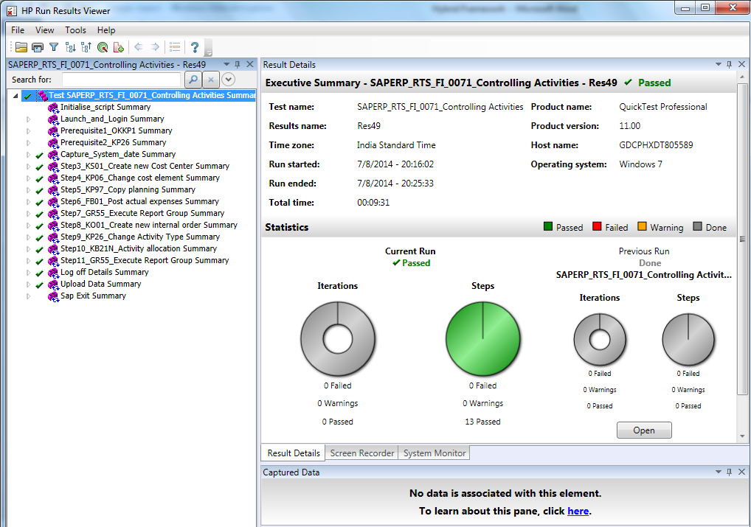

1. **PDF Report of the Execution Flow**: With the help of third party plug-in ‘**Genilogix QCeApprove**’ the executed steps can be saved in a pdf format. The unique feature of this Plug-in enables the end user to download complete execution result in PDF format with which one can easily validate the scenario.

PDF contains the following details,

* Manual Step description
* Expected Result
* Actual Result(s) with Screen shots captured during the execution of Automation Test Script.

# AUTOMATION DESIGN PROCESS :

1. **Review of previous evidence reports for understanding scenario**

Automation Resource should go through the PDF reports of previous execution done manually to understand the flow of test script.

1. **Automation feasibility analysis of Manual scripts.**

Automation Resource should analyse the test script functionality to decide whether the scenario is Automatable, Semi-Automatable or Not Automatable.

1. **Questions Preparation & Internal Review of manual test scripts eligible for Automation**

Automation Resource should prepare the list of questions on which clarification is needed from SME and should conduct an internal peer review on the analysis done for automation.

1. **Schedule meetings with SMEs for the clarification on Questions.**

Automation resource should schedule meetings with SMEs to get the clarification on the questions prepared.

1. **Ensure System/Instance readiness**

Automation Resource needs to request for SAP instance access, where the Automation design is to be done

1. **Ensure Test Data readiness.**

Automation Resource needs to send a mail to SMEs by requesting the Test Data required for the scenario to be automated

1. **Test Bed preparation for Automation**

As per the tool confirmation from business, Automation resource should install all the required software in his/her machine to kick-off the Automation Design

1. **Publishing script Automation Status**

Automation resource should publish a Daily status report to enable Business, stakeholders & SMEs to know the current status of Automation design

1. **Dry Run of Completed Automated Scripts**

Automation Resource should execute the initial draft of completely Automated script in Informal ALM to make sure whether it is working as expected or not.

1. **Review of Automated Scripts**

Peer reviews should be done on the automated script to identify the errors and code Enhancements

1. **PDF report Generation & Review**

Automation resource should complete the execution in Informal ALM, generate a PDF Report and should send it to SMEs for Review

1. **Verification Points documentation & Review**

Automation resource should document the Verification points implemented in automated script to a given template and send it to SAP COE leads for Review

1. **Automated script update based on Suggestions from SMEs & Functional Leads**

Automation Resource should update the code in the automated script as per the suggestions from SMEs and SAP COE Leads.

1. **Uploading Automated script to In-Formal ALM**

Automation Resource should upload the Final automated script to Test plan of Informal ALM and should complete all the approval with the help of dummy IDs provided by the business.

1. **Execution & Sign-Off in In-Formal ALM**

Automation resource should execute the final automated script uploaded to informal ALM, generate the final PDF report and sent it to the business for final Sign-Off in Informal ALM

1. **Uploading Automated script to Formal ALM**

After getting the confirmation from business, Automation should upload the script to Test Plan of Formal ALM

1. **Completing the Automated script Approvals for execution**

Automation Resource should change the status of automated script to “Ready for Approval” and should request test plan lead to continue with Approvals.

1. **Execution & Sign-Off in Formal ALM**

Automation Resource should execute the Approved automated script in Test Lab of Formal ALM, send the run details to VMs for Approval and for Final Sign-Off.

# AUTOMATED SCRIPTS EXECUTION PROCESS:

1. **Getting the Execution scope regression/release from Business**

Automation resource should request business for the scope of test script to be execution for the release.

1. **Requesting instance access for execution**

Automation Resource needs to request for SAP instance access, where the Regression execution is to be done

1. **Requesting for Prerequisites data setup**

Automation Resource needs to send a mail to SMEs by requesting the Prerequisite data setup for the list of scenarios in scope for current regression testing

1. **Creating Folder structure in Test LAB of ALM(Informal & Formal) for both Automated and Manual scripts & confirming with Client Test manager**

Automation resource should create the Folders structure for regression testing in Test Lab of ALM under the respective release and should inform the business for Approval

1. **Pulling the Automated & Manual Test scripts to the respective folders for execution**

Automation Resource should pull the regression test scripts from Test Plan to Test Lab in ALM.

1. **Informal execution Kick-Off**

As per the regression plan, Automation resource should kick-off the informal execution. Execution will be done to identify prerequisite and configuration issues

1. **Reporting the issues faced during the execution**

Automation Resource should report issues faced during the informal run to the SMEs for resolution

1. **re-execution of Automated scripts after the issue resolution**

Automation resource should re-execute and close the scenarios in which the issues are identified.

1. **Formal execution Kick-Off**

Automation Resource should kick-Off the Formal execution after all the scripts in-scope for regression are passed in Informal ALM.

1. **Raising Defects for functional issue found during the Formal Run**

Automation resource should provide the necessary information to the test manger regarding the functional issue for a defect need to be raised in Formal ALM.

1. **re-execution of Automated scripts after the Defect resolution**

Automation resource should re-execute the failed test scripts after the defects resolution in order to confirm the excepted functionality

1. **Ensuring the approvals of all runs by Validation Managers**

Automation resource should change the approval status of All passed runs (Automation & Manual) in Test Lab to “Ready for Approval” and inform the Validation Manager (VM) for review.

# REFERANCE TEMPLATES:

Below are the reference templates for Test Data & Verification point documentation.

1. Sample Test Data Sheet



b). Sample Approved Verification Point Document



c). Sample Status Template



# Document version control table:

|  |  |  |  |
| --- | --- | --- | --- |
| **Version Control** | | | |
| **Version Number** | **Creation Date** | **Author** | **Reviewed & Approved by** |
| V1.0 | 16.03.2016 | Phani Chandra Reddy. S  (502126745) | 1. Talari Surendra (502282139) 2. Naraharisetty Sridhar (502582267)  3. Talikota Satish (212363836) |
|  |  |  |  |
|  |  |  |  |
|  |  |  |  |